Great Books for People Who Don’t Like To Read
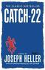
- Catch-22, Joseph Heller An American Bombardier is mad and frantic because thousands of people keep trying to kill him and his friends in World War II told with humor and bitterness

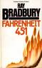
- Fahrenheit 451, Ray Bradbury In the future firemen are sent out to destroy books and they burn at 451 degrees. A group of people get together a memorize the books, so that they will not be destroyed but live in people's minds and can be recited

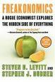
- Freakonomics: A Rogue Economist Explores the Hidden Side of Everything, Steven D. Levitt Which is more dangerous a gun or swimming pool? What do schoolteachers and sumo wrestlers have in common? Why do drug dealers still live with their moms? How much do parents really matter? How did the legalization of abortion affect the rate of violent crimes? Not typical questions for a economist to ask.....

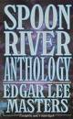
- Spoon River Anthology, Edgar Lee Masters Series of poetic Monologues by 244 inhabitants of a Midwestern cemetery who speak their own epitaphs therefore showing the motivations of their lives

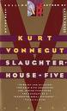
- Slaughterhouse-Five, Kurt Vonnegut Join Billy Pilgrim on his search for hope from the bombing of Dresen in World War II to the journey to distant planet.

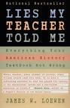
- Lies My Teacher Told Me, James Loewen Critiques 12 American history textbooks arguing that they contain misinformation, fail to connect present issues with past events, and lack suspense and drama. Retells events in American history to combat these problems.

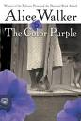
- The Color Purple, Alice Walker Life wasn't easy for Celie. But she knew how to survive, needing little to get by. Then her husband's lover blasted into her world and gave Celie the courage to ask for more of life.

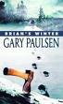
- Brian’s Winter, Gary Paulsen In Gary Paulsen's classic novel Hatchet, thirteen-year-old Brain Robeson is stranded in the Canadian wilderness. To survive, he must rely on his intelligence, his instincts, and one tool: a hatchet. Finally as millions of readers know, his is rescued at the end of the summer. But what if Brain hadn't been rescued? What if Brain had been left to confront his deadliest enemy-winter?

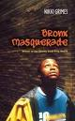
- Bronx Masquerade, Nikki Grimes While studying the Harlem Renaissance, students at at Bronx High School read aloud poems they've written revealing their innermost thoughts and fears to their formerly clueless classmates.

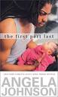

- The First Part Last, Angela Johnson
The story of Bobby a typical urban teenage boy. He gets his girlfriend pregnant and his life changes. While Nia and Bobby struggle to decide what to do with their baby, Bobby has to fact life tough decisions
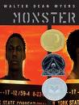
- Monster, Walter Dean Myers
The story of a young man caught in a crime put into the justice system and the way his life changed.
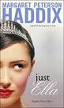
- Just Ella, Margaret Peterson In this continuation of the Cinderella story, 15 year old Ella finds that accepting Prince Charming's proposal ensnares her in a suffocating tangle of palace rules and royal etiquette so she plots to escape

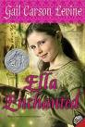

- Ella Enchanted, Gail Carson Levine A little different telling of the Cinderella story with enchantment working against Cinderella this time.
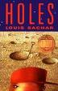

- Holes, Louis Sachar Stanley Yelnats is unjustly sent to Camp Green Lake as a punishment for a crime. While there he realizes that everyone is digging holes that are 5 by 5 and looking for something

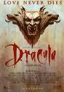
- Dracula, Bram Stoker The story of a man sent to Europe and to a castle that seems deserted and the count is a strange host. Dracula must be destroyed before he kills those close to Jonathan Harker.

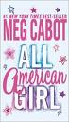
- All American Girl, Meg Cabot A sophomore girl stops a presidential assassination attempt, is appointed teen ambassador to the United Nations, and catches the eye of the very cute first son.

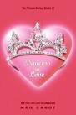
- Princess in Love, Meg Cabot She's a princess, for starters. She also lives in New York City. And while she's no super-model, mirrors do not crack at her reflection. Best of all, she finally has a boyfriend.

- Speak, Laurie Anderson The story of a young girl who experiences a rape at a party but does not seem to be able to tell anyone until she has gone through a year of school.

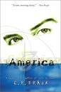
- America, E.R. Frank A boy named America, a part-black, part-white, part-anything boy who has spent many years in institutions for disturbed antisocial behavior, tries to piece his life together

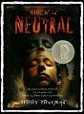
- Stuck in Neutral, Terry Trueman Fourteen-year-old Shawn McDaniel thinks his father may be planning to kill him because he is physically handicapped.

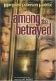
- Among the Betrayed, Margaret Peterson Haddix Nina has been caught by the police for being one child too many and now the she faces death or torture unless she betrays 3 other children

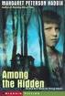
- Among the Hidden, Margaret Peterson Haddix In this new world, parents are allowed to have only 2 children, so the 3rd child is forbidden and if you have one, it is hidden. In this world Lucke is a 3rd child. One day he sees another child who is also hidden and the adventure begins

