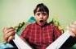
45 Books Reluctant Readers Love to Read
(list constructed by Kelly Gallagher)
Coming of Age/Peer Pressure/Relationships
1. 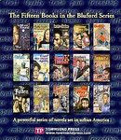 The Bluford series, Paul Langan.
Life in an inner city school.

2. 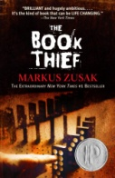 The Book Thief, Markus Zusak.
Death narrates this story of a young girl who finds solace in books during the Holocaust.

3. 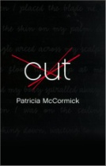 Cut, Patricia McCormick.
Callie, a fifteen-year old, is a “cutter” who seeks help for her self-destruction.

4. 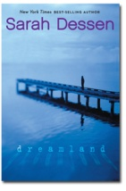 Dreamland, Sarah Dessen.
This book explores the consequences of having an abusive boyfriend.

5. 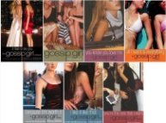 Gossip Girl series, Cecily Von Ziegesar.
Life in side a New York City jet set private school.

6. 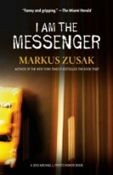 I am the Messenger, Markus Zusak.
A botched bank robbery changes a nineteen-year-old’s life.

7. 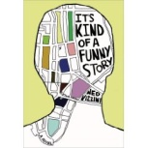 It’s Kind of a Funny Story, Ned Vizzini.
A teen seeks counseling in a psychiatric hospital.

8. 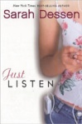 Just Listen, Sarah Dessen.
An incident at a high school party has far-reaching consequences.

9. 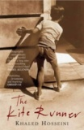 The Kite Runner, Khaled Hosseini.
Two young boys in 1970s Afghanistan take very different paths.

10. 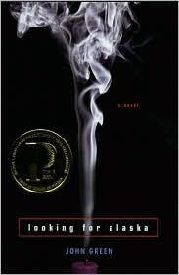 Looking for Alaska, John Green.
Miles, 16, is an outcast sent to a boarding school.

11. 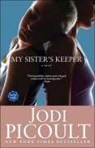 My Sister’s Keeper, Jodi Picoult.
Examines the difficult choices a family must make when one of the children is diagnosed with a life-threatening illness.

12. 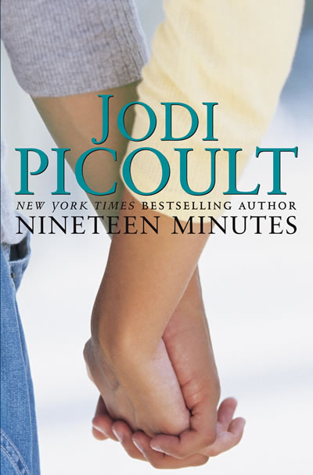 Nineteen Minutes, Jodi Picoult.
Another delicate topic: the consequences of a high school shooting.

13. 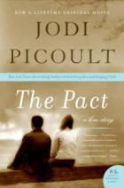 The Pact, Jodie Picoult.
A teenage suicide has devastating consequences for two families.

14. The Perks of Being a Wallflower, Stephen Chbosky.
Charlie, a freshman, tries to find his way in a high school.

15. 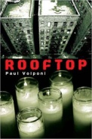 Rooftop, Paul Volponi.
A shooting becomes a focal point for social justice.

16. 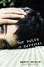 The Rules of Survival, Nancy Werlin.
The story of three siblings struggling to overcome child abuse.

17. 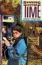 Running Out of Time, Margaret Peterson Haddix.
Jessica, who thinks it is 1840, is more than surprised to find out it is really 2006.

18. 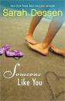 Someone Like You, Sarah Dessen.
Two best friends lean on each other when a calamity occurs.

19. 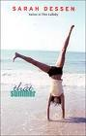 That Summer, Sarah Dessen.
A teenage girl deals with her parents’ divorce.

20. 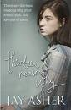 Thirteen Reasons Why, Jay Asher.
A teenager receives haunting audiotapes after a suicide.

21. 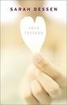 This Lullaby, Sarah Dessen.
A modern-day teen romance.

22. 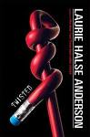 Twisted, Laureie Halse Anderson.
Tyler, busted for tagging, tries to find his way through his senior year.

23. 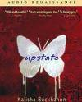 Upstate, Kalisha Buckhanon.
Two lovers are separated by a horrendous crime.

FANTASY/ SCIENCE FICTION/ VAMPIRE

24. 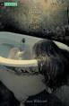 A Certain Slant of Light, Laura Whitcomb.
Helen died 130 years ago, but she’s still around.

25. Cirque du Freak series, Darren Shan.
There is more to a traveling freak show than meets the eye.

26. 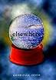 Elsewhere, Gabrielle Zebin.
Liz is getting younger, not older, every day.

27. 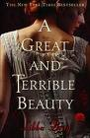 A Great and Terrible Beauty, Libba Bray.
The School Library journal calls this novel “an interesting combination of fantasy, light horror, and historical fiction, with a dash of romance thrown in for good measure.”

28. 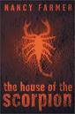 House of the Scorpion, Nancy Farmer.
In the future, a scientist brings a number of clones to life.

29. 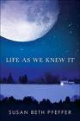 Life as We Knew It, Susan Beth Pfefs,
A meteor collides with the moon, with disastrous results for Earthlings.

30. 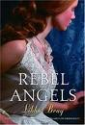 Rebel Angels, Libba Bray.
A sequel to A Great and Terrible Beauty.

31. 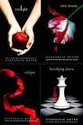 The Twilight Saga series. Stephen Meyer.
A teenage romance with a vampire twist.

32. 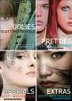 The Uglies series, Scott Westerfeld.
Life in a futuristic society where everyone is “ugly.

33. 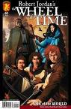 Wheel of time series, Robert Jordan.
The world has been broken by a phenomenal power in this series that is
reminiscent of J.R.R. Tolkien.

34. 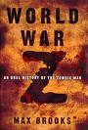 World War Z: An Oral History of the Zombie War, Max Brooks.
The world is threatened by a zombie invasion.

MEMOIR AND NONFICTION

35. 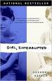 Girl, Interrupted, Susanna Kaysen.
A sixteen-year old is hospitalized in a psychiatric hospital.

36. 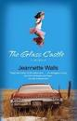 The Glass Castle, Jeanette Walls.
Another account of growing up in an eccentric, dysfunctional family.

37. 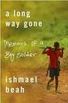 A Long Way Gone: Memoirs of a Boy Soldier, Ishmael Beah.
A twelve-year-old’s account of surviving civil war in Sierra Leone.

38. 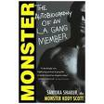 Monster: The Autobiography of an L.A. Gang Member, Sanyika Shakur.
The personal account of an L.A. gangbanger.

39. 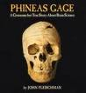 Phineas Gage:A Gruesome but True Story About Brain Science, John Fleischman
The incredible story of a recovery from severe trauma, and what it taught the scientific community.

40. 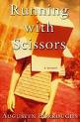 Running with Scissors, Augusten Burroughs.
An account of growing up in an eccentric, dysfunctional family.

41. 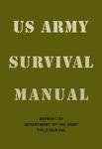 U.S. Army Survival Handbook, Department of the Army.
How to survive under the most adverse conditions.

SPORTS
42. 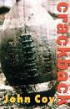 Crackback, John Coy.
The trials and tribulations of teenage life, woven through the lens of a high school football team.

43. 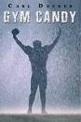 Gym Candy, Carl Deuker.
Mick Johnson, high school football star, considers using steroids.

MYSTERY

44. 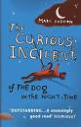 The Curious Incident of the Dog in the Night-Time, Mark Haddon.
A poodle, Wellington, has been murdered. Christopher, who is autistic, is on the case.

45. 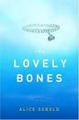 The Lovely Bones, Alice Sebold.
Susie Salmon recalls her murder from heaven (10th grade curriculum)

